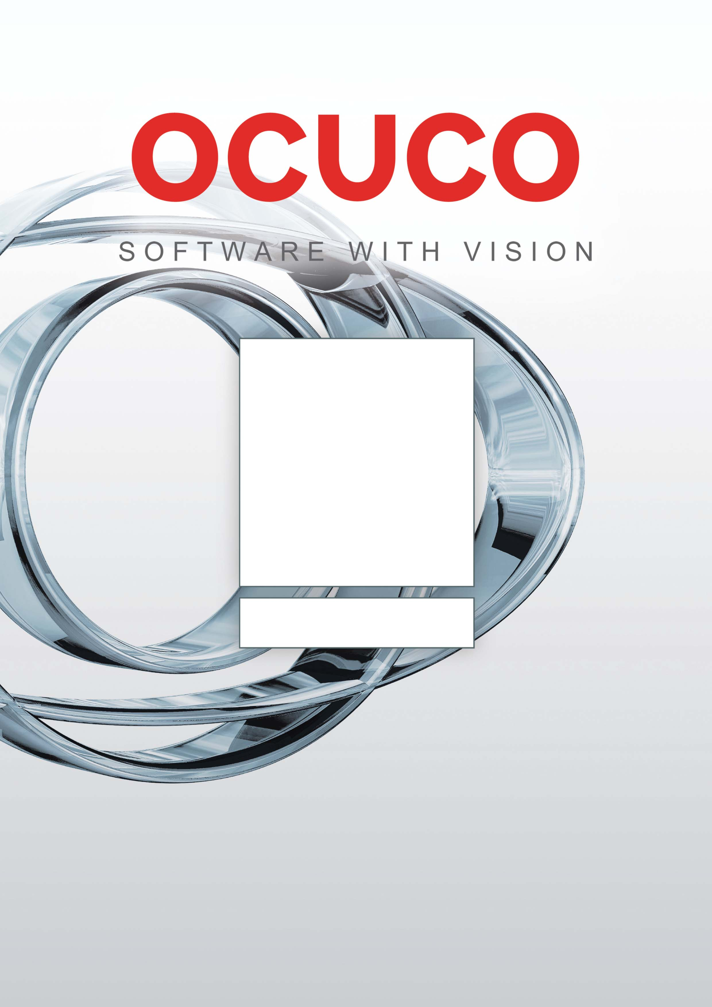



Pharmacy Management Software

Integra
Contents

Part 1 : Company Information

Welcome to Ocuco 5
Introduction 5
Reasons why you should choose Integra Rx 6
Company Background 7
Ownership and corporate structure 7
Brief history of Ocuco 7
Company Values 8
Personnel 9
Staff employed at Ocuco split between Offices 9
Qualifications and experience of staff supporting the proposed services 9
Nature of business activities 11
Products and Services 11
Financial Information 12
Service Levels 13
Ocuco – Responsibilities 13
Ocuco’s Own Core Support Service 13
Ocuco’s 3rd Party Support Management Service 13
Issue Prioritisation and Response Times 14
Data Protection of Health Related information. 14
Customer and End User responsibilities 15
Issue Reporting Procedure 15
Exclusion of Responsibility and Liability 15
Service Availability 16
Customer Support mechanisms 16

Part 2 : Integra Rx User Guide
Integra Rx – Shortcuts sheet 19
Features 30

Part 3 : Reports Pack
Practice Performance Report 32
Practice Sale Analysis 34
Category Sales Analysis 36
Daily Prescription Report 38
Controlled Drug Report 40
Patient Analysis 42
Product Analysis Report 44
Stock Take Adjustments Report 46
MDS Cassette Sheet 48
MAR Sheet weekly format 50
MAR Sheet monthly format (days horizontal) 52
MAR Sheet monthly format (days vertical) 54
MAR Order Form 56



Part 1 :
Company Information

Welcome to Ocuco

Introduction
Many IT companies spend considerable resources advertising the future of pharmacy technology. At Ocuco, our vision is different: Pharmacy is providing patient care today. Patients seek professional advice now, and the Pharmacist wants to be able to process their scripts rapidly and efficiently, in order to spend more time giving advice and providing healthcare.
Ocuco sees Irish Pharmacist wanting the staff in their Pharmacies to spend time doing what they do best, looking after their Customers and Patients. This is why in Ocuco we believe that Integra is the best Pharmacy Management System: it is feature-rich, stable and built on a very robust architecture, while being intuitive, easy to use and efficient.
Ocuco perceives Irish Pharmacist being very serious about managing their pharmacy activities in an increasingly competitive sector, where knowledge management and availability of information is the key not only to been profitability, but to survival.
This document will demonstrate how Ocuco can enhance the patient’s experience as they re-visit your practice, by providing you with a fast and easy-to use Windows-based Dispensary Management system which will enable you to fulfil tomorrow’s requirements today.
We look forward to being part of this considerable change in your practice as you switch to Windows and to aiding you to achieve all the benefits from the use of Integra Rx.

Reasons why you should choose Integra Rx

Integra Rx has been built from the ground up to be used by a Pharmacist. Its ease of use is unrivalled in the industry, and it is the only dispensing system in Ireland based on Microsoft Windows that can claim to be in its 2nd Generation.

Integra Rx unique features:
- Automatic DPS co-payment tracking
- Unique Prescription Cash Management module
- 2nd Generation PCRS Claims (XML), allowing you to correct exceptions before the early payment deadline
- No transaction fees on PCRS Claims
- Groundbreaking Monitored Dosage System for Nursing Homes and private patients.
- Possibly the best example of sheer volume of time that could be saved with Integra Rx is the MDS module - We have benchmarked existing users of the QIC Script MDS module where hours are needed to re-key repeat Phased dispenses where the end of a phase has been reached. This time lot and errors that occur would all be removed as repeating all patients in a 70 bed Nursing Home and printing their Cassette sheets (Nomad) or labels, takes 20 minutes.
- Unique Methadone Dosage module
- SMS text messaging sends Prescription Reminder and Prescription Collection messages directly to patient mobile phones and recoups the cost of this service from the patient
- Unique “Script Due” patient search filter, allows you to select patients due for repeat prescriptions today allowing you to prepare regular patients scripts. The Automatic Collection SMS message will then be sent to prompt patients to present for their prescription
- Integra HO - Multi-Store System, proven to be scalable from 1 to over 200 sites
- Centralised selected store functions
- Global visibility of multiple stores
- Unique data mining and business analysis technology: adds real value through the representation of the facts about the pharmacy, staff and patients. Integra materialises the value of the information gathered in the pharmacy by allowing it to be easily and quickly analysed. Most software packages offer some form of reporting capabilities, but Integra proposes a unique analytics offering, providing new and innovative clinical and retail analysis.

Integra HO features:
- Having aggregated data available for reporting at your Head Office, will give true control of pharmacy operations. Ocuco have obtained invaluable experience with this type of integration in our partnership with Vision Express.
From a store’s perspective, mundane daily, weekly and monthly administrative tasks currently required to update head office of current events will be done away with, leaving staff more time for Patients and value added activities.
Combining this with powerful reporting capabilities, and with the ease of maintaining consolidated data for all stores connected to the system (“update-once” technology) can result in saving hundreds of man hours.

Company Background

Ocuco develops and supports software solutions for pharmacies and opticians, as well as for private ophthalmology practices and hospitals.
Ocuco was incorporated in 1997 but its founders had already established a strong presence in the ophthalmic market in 1993.
Ocuco expanded into providing Pharmacy Management Software to Pharmacies in 1999.

Ownership and corporate structure
Ocuco is an independent Company, fully owned by its Management and Shareholders, most of which are also its employees.
Ocuco Holdings operates as a Group. The Head Office of the Group is located in Ireland, and is the centre where international management activities, Software Development and most Customer Support activities are based.
Pharmacy Management Software is supplied and supported exclusively from the Dublin centre.
Ocuco Holdings includes the following Companies (as per August 31st 2007):
- Ocuco Limited is based in Dublin and Pharmacy Management Software is supplied and supported exclusively from the Dublin Centre.
- OcucoRelcon Limited is the UK division based in Cardiff, whose main emphasis is the distribution of optical practice management systems for Ireland and the UK
- DRS Computer Systems, based near Oxford and specialising in management software for Optical Labs.
- Ocuco Inc, a US-based company supplying software to drive optical lab machines.

Brief history of Ocuco
- The Computer Department Ltd (est’d 1993) designed and developed the first Windows™ based practice management solution for opticians. TCDL was founded by Ocuco’s current CEO and majority shareholder, Leo MacCanna.
- Clinical Software Ltd (since 1992), offered a DOS based clinical patient recording systems for ophthalmologists
- These two companies merged in 1997 to form Ocuco Ltd
- Its product line for Opticians and Ophthalmologists, Acuitas, is widely acclaimed in Ireland and the UK, and it is implemented in both private practices and large hospitals. Acuitas Enterprise was the first multi-practice patient relationship management solution of its kind and was first released in 1999
- In February 2000, Ocuco entered the Pharmacy market, having been chosen to develop a Pharmacy Dispensary application based on the success of the Acuitas suite of software and its acceptance in a similar environment. The software was developed on the requirements, the specifications and input of a group of Irish pharmacists.
- With its Prometheus product line, comprising a Dispensary PMR system, an EPoS system, and an Enterprise solution. Prometheus was the only Windows / Oracle / Enterprise solution for the Pharmacy market available in Ireland – which remains to be the case today.
- In 2006, Ocuco decided to rewrite most of its Prometheus product line, to update its workflows, internal mechanisms and components, and make it a true 21st Century system.
The Integra Pharmacy Management Suite was born.

Company Values
Ocuco operates under sound, established principles of fairness and socially responsible business practices, among which good business practice, employee development, concern for the environment, and investment in the community.
- At Ocuco we continually move our products forward
- We develop on the latest, most advanced platforms and environments
- New features and enhancements are continually added to the products
- Our development is driven by our Customer’s needs and feedback
- Independent user groups are included in the development of each product
- To show ‘clear blue water’ between Ocuco and competitors in both software and services

Ocuco FIRSTs
To support our Company Values and our Mission Statement, we have introduced many 'FIRSTs'.
Here are some of the most significant, applicable to our local markets:
- FIRST Windows™ based Dispensary System (2000)
- FIRST with Direct Electronic Claiming to the GMS Payments Board (now the PCRS)
- FIRST Fully Integrated EPoS and Dispensary System (2001)
- FIRST Multi-practice System
- FIRST Implementation of Thermal Printers for Prescription Labels
- FIRST Practice management System with Enterprise functions (2001)

Personnel

The Ocuco Group employs ca. 55 people (August 31st 2007). The numbers are growing to reflect the expansion in our business and the commitment to our Customers.
Ocuco offers the best Support in the industry, with a very high level of measurable customer satisfaction, quick issue resolution time and full tracking on progress. All our Support engineers are IT graduates, and staff turnover is very stable. Ocuco is a great place to work and develop.

Staff employed at Ocuco split between Offices
Staff is currently employed in three centres; these numbers only show the relevant Departments:
 | Total staff | Support/ Helpdesk | Training/PSD | Development | Managerial | Other
Blanchardstown | 35 | 7 | 5 | 9 | 6 | 8
Cardiff, | 16 | 4 | 3 | 5 | 4 | -
Oxford. | 4 | - | - | 3 | 1 | -

Qualifications and experience of staff supporting the proposed services
- All our Engineers have graduated with at least a Higher Educational & Training Awards Council accreditation. Most of our Engineers also have other qualifications and accreditations.
- All our Engineers receive professional training from our training department. This is an adapted version of the training provided to our customers and is of a very high standard, being structured around discrete modules based on the functional units of the application and the steps of the
- Frequent Inter-departmental training takes place under an internal cross-breeding programme called “The Well-Rounded Engineer”. Within this programme, all Engineers spend some time in our Development department where they can experience how products are developed and increase their overall understanding of the products.
- All of our Engineers have access to online multimedia training where they can take refresher courses if required. Online training provides a self-certification method for individual aspects of the application and, by extension, of the customer’s workflow.
- All our Engineers take part in an exchange programme with the other locations (Cardiff and Oxford) where they receive training on specific products and procedures.
- Finally, all engineers spend some time on site with selected customers to get first hand experience of how our applications are implemented in real business environments.
All staff are eligible for study grants. The suitability of the courses chosen is assessed on a per case basis, and grants and/or study leave is granted according to specific needs. The success obtained by the student in the courses is included in their annual review, and contributes to the global on-going assessment of the individual – therefore people can gain company appreciation while developing their personal knowledge and skills.
When new employees are introduced to the support team, Ocuco has a standard, documented procedure in place for their induction and for ensuring that they will rapidly attain the standards of customer satisfaction Ocuco requires. This procedure includes:
- Training in all of our products carried out by our Training Department.
- Introduction to procedures employed within the team by the Team Lead.
- Training on call logging and issue handling carried out by one of our senior Engineers.

Nature of business activities

Ocuco is a forward-looking Software Development Company with a solid reputation built on customer satisfaction and support, and first-class innovation.
Ocuco specialise in software for medical professionals:
- Dispensing Pharmacists (Integra, Pharmacy Management Software)
- Optometrists (Acuitas™ Retail, Acuitas™ Optical, Focus™, and many others)
- Ophthalmologists (Acuitas™ Clinical, Acuitas™ Imaging)
Ocuco gained its first user in April 1993, and have used the 14 years of experience to improve and update the computer applications and services provided.

Products and Services
Integra RX
- Ocuco’s Second Generation Microsoft Windows-based Dispensary System
- Dispense prescriptions with maximum efficiency and minimum effort.
Integra POS
- The Ocuco Epos Solution
- The Intuitive Point of Sale, Integrated with the Dispensary.
Integra HO
- The first Head Office centralised system. Supports Integra RX and Integra POS
- Centralised reporting, price control and store management for Pharmacy groups.
FOCUS™
- Patient relationship management for high street opticians
Acuitas Optical
- Integrated paperless clinical records with dispensing for high street opticians
Acuitas Retail
- Integrated paperless clinical records with validated dispensing and Epos for high street opticians
Acuitas Clinical
- Electronic patient records for ophthalmologists
The above are the mainstream products developed by the Ocuco Group. Ocuco also supplies solutions for optical lab management and for driving optical lab machines, the description of which is beyond the scope of this Document.

Financial Information

Please find hereafter a summary of financial information for 2004, 2005 and 2006. Our Accounts are audited by KPMG. A copy of audited accounts is available on request.
Data is expressed in thousands of Euro. Our year end is August 31st.
 | 2006 | 2005 | 2004
Turnover | 4160 | 3991 | 1394
EBITDA | 693 | 816 | 194
Profit after tax | 573 | 816 | 194
Current assets | 3280 | 1767 | 669
Current liabilities | 1859 | 948 | 600
Non-current (fixed) assets | 2089 | 118 | 53
Non-current liabilities | 0 | 0 | 0
Net outstanding debt at the end of each financial year | 0 | 0 | 0
Cash and cash equivalents held at the end of each financial year | 376 | 1370 | 64
Number of Full Time Employees (FTEs) | 33 | 27 | 15
Financial year-end date | 31 August 2006 | 31 August 2005 | 31 August 2004

In July 2007 the Ocuco Group filed the 2006 audited financial results for the year ending 31st August 2006. The Group comprises Practice Management Software specialists Ocuco Limited, OcucoRelcon and Lab Software business DRS Computing.
Total company income was up 4% to €4.2m (£2.8m). Profit fell 30% to €573,206 (£384,048) due to a substantial increase in Research and Development. Only one month’s accounts of now merged Relcon Software Limited accounts are included in the figures, these would bring total revenues for the group in the period to over €5.7m (£4m).
In market share terms the Group made substantial progress, with the total number of supported practices growing over 300% from 326 to over 1,000, representing more than 6,000 desktops using the Acuitas and Focus Practice Management Software across the UK and Ireland.
Pharmacy projects and support revenue represent about 12% of turnover for Ocuco Limited. However, Ocuco is committed to their Pharmacy customers, as they currently represent over 15% of our Customer base. Witness is the development of a whole new generation of Pharmacy software.

Service Levels

This Section outlines the Terms of the Service Level Agreement. Please note that the only legally binding Document is the Service Level Agreement itself, which will be signed separately on acceptance of the contract for supply of the software.
The Service Level Agreement defines the basis on which technical support services are provided between Ocuco and the customer, and the responsibilities that each party must take in order for these services to be provided.

Ocuco – Responsibilities
Ocuco operates a one-stop shop for Ocuco customers, supporting the operation, upkeep, use and upgrading of Ocuco Products and related hardware (through customer pre-designated 3rd party hardware support suppliers).
Ocuco’s service commitment is to provide customers and users with a simple path for resolution of all system related issues through:

Ocuco’s Own Core Support Service
Ocuco maintains a team of qualified support engineers dedicated to the resolution of Ocuco software product issues as they arise.
- Supporting Ocuco Software operability, maintenance and upgrade.
- Supporting Oracle Database operability, maintenance and upgrade.
- Supporting the specific configuration of remote links to Ocuco from “known good”, pre-tested connectivity related hardware and software.
- Supporting the specific configuration of customer system backups – solely as it relates to starting and stopping Oracle database services.
- Supporting the specific configuration of settings of “known good” label and receipt printers once they are set up and verified as working from the perspective of the operating system.

Ocuco’s 3rd Party Support Management Service
Ocuco Support will arrange and / or advise on the 3rd Party support of most other system issues on the customer’s behalf with the customer’s pre-designated hardware support provider(s) (please refer to Schedule C in this Agreement Document – for advice on securing Hardware Support Agreements). This service includes up to 15 minutes of Ocuco’s direct support in non Ocuco Software related issues within Ocuco’s expertise, before 3rd Party Service providers are contacted;
- Windows Operating System Issues.
- General PC Hardware and Supporting 3rd Party Software related issues.
- Network and Networking related issues.
- General Backup configuration and issues.
- Printer setup related issues.
- Internet connectivity setup issues.
- Remote Control software installation and connection testing.
- Hardware upgrade issues.
- General Anti Virus Application Issues.

Service Performance and Quality Metrics

- 95% of telephone calls will be answered within 4 rings.
- Our support engineers will always give their name.
- Our support engineers will always be courteous and polite.
- Every contact and progression on any issue will be logged in our tracking systems.
- If any matter cannot be resolved immediately support engineers will provide the customer representative with a unique issue number from our tracking systems to track the issue to its conclusion.

Issue Prioritisation and Response Times
Issue Priority | Response
Critical.  Whereby a problem with the configuration or operation of the Ocuco Software is preventing a customer site from making sales and / or preventing users from being able to work with the business critical functionality of the software. | Ocuco shall use its reasonable endeavours to respond within 2 working hours of generation of an Issue number in its Helpdesk Application.
Major.  Whereby a problem with the configuration or operation of the Ocuco Software is inhibiting / delaying but not preventing a customer site from making sales and / or inhibiting / delaying but not preventing users from being able to work with the business critical functionality of the software. | Ocuco shall use its reasonable endeavours to respond within 4 working hours of generation of an Issue number in its Helpdesk Application.
Minor  Whereby a problem with the configuration or operation of the Ocuco Software is preventing, inhibiting or delaying a customer site from working with non-business critical functionality of the software. | Ocuco shall use its reasonable endeavours to respond within 8 working hours of generation of an Issue number in its Helpdesk Application.
Query  Whereby a minor issue, status enquiry or query unrelated to the proper functioning or operation of the Ocuco Software is communicated to Ocuco Support for research / response. | Ocuco shall use its reasonable endeavours to respond within 3 working days of generation of an Issue number in its Helpdesk Application.

Data Protection of Health Related information.
Ocuco are a registered Data Processor with the Data Protection Commission of Ireland. Ocuco and its staff support and apply best practice Data Protection Policies for confidentiality, “intended use”, and deletion of health related data upon completion of work.
Ocuco will never link into a customer system to view, copy or manipulate patient data, unless in response to a specific request to support a particular issue and by agreement with the customer.

Customer and End User responsibilities
In order for Ocuco to meet the service performance and quality metrics (Section 2.3), set out above, it is AGREED that the customer accepts the risk and has sole responsibility:
- To ensure all end-users of the software are competent and fully trained in its proper use.
- To maintain and run an up to date Anti Virus application on the entire system, with daily hard drive scanning and regular update of virus definition files.
- To maintain the physical network cabling in working order.
- To secure and protect their own data, and to ensure full daily data backups of the server, and any significant business data are performed, and stored offsite appropriately.
- To train and designate a “technical contact” for Ocuco engineers to work with as a preferred point of contact for product and general technical issues.
- To maintain a separate contract with a 3rd party Hardware Support Supplier at all times, and notify Ocuco of the identity and contact details of same.
- To provide Ocuco with up to date, useable staff, practice and system contact details, which must include a telephone number for voice, working data link details for remote system access, a fax number and a monitored email address.
- To provide Ocuco with exclusive, uninterrupted physical (onsite) or remote access (over a phone line, or “always on” internet connection) to the system (Servers and Client PCs) when this is required for maintenance or updates to Ocuco software.
- To ensure that no 3rd party software is installed on any machine that may interfere with the operation or support of Ocuco’s software, without prior written consent.
- To ensure their systems are protected from the risks of adverse affects resulting from power failures.
- To actively ensure that anyone in contact with Ocuco engineers or accounts staff maintain a constructive and respectful manner at all times; avoiding any perception of abusive or demeaning language whatever the situation.

Issue Reporting Procedure
When encountering a new issue with the product or service, the customer’s authorised representative shall immediately contact Ocuco’s support services by telephone, fax or email – providing a full description of the issue and / or its symptoms. At this time, Ocuco Engineers may need to ask further questions of the contact to properly diagnose and accurately record the relevant behaviour of the system. It may then be appropriate for Ocuco to request a remote link to further diagnose or retrieve log files to aid in diagnosis.
Upon initial communication of a new issue, its detail will be entered into Ocuco’s Helpdesk System – which will generate a unique Issue number. If the issue cannot be resolved immediately, an issue number will normally be communicated to the user upon generation (by phone) or within 60 minutes (by email).
Ocuco will analyse and assign the Issue Category on generation of the Issue Number, and will respond accordingly.
On receipt, the customer is obliged to record and reference this issue number in any future correspondence within its life.
The Customer accepts that the availability of the appropriate customer representative to assist Ocuco Support Engineers throughout the issue life cycle is directly related to its resolution time.

Exclusion of Responsibility and Liability
Ocuco’s responsibilities and obligations under this agreement exclude the diagnosis and rectification of any faults resulting from, or the creation and application of fixes necessitated or requested as a result of:
- Failure to carry out any steps outlined in the section “Customer and User Responsibilities” (Section 3) of this agreement.
- The improper use, operation or neglect of the software by the customer and / or end User – and resultant rectification of data loss, invalidity or corruption.
- The modification of the software or its merger (in whole or in part) with any other software by non-Ocuco staff without prior written consent.
- The use of the software on equipment other than compatible equipment specified by the Ocuco; or the use of the software for any purpose for which it was not designed.
- Software releases in relation to which Ocuco services have been withdrawn (including but not limited to a software versions issued more than 12 months previously)
- Negligence or fault of the customer or end user.
- The withdrawal of support as a result of non-payment of outstanding fees to Ocuco.

Service Availability
Excluding extraordinary circumstances, Ocuco Support Services will be available through the following channels.

Standard Technical Support
As part of the terms and conditions of this Service Level Agreement, Customers with current Support Contracts can contact Ocuco’s Direct Support at local call rates from anywhere in Ireland, between the hours of 9am to 6pm local time, Monday to Friday.

Out of Hours Technical Support
As a further service, external to the terms and conditions of Ocuco’s standard support offering, Customers with current Support Contracts can utilise Ocuco’s Out of Hours Direct Support between the hours of:
- 8am - 9am Monday to Friday
- 6pm - 8pm Monday to Thursday
- 9am to 11am Saturday.

Times when Ocuco Support will not operate
Ocuco Technical Support will normally be unavailable:
- On New Year’s Day - 1st January,
- On Christmas Day - 25th December, and
- On St. Stephen’s Day - 26th December.

Customer Support mechanisms
As stated above, Ocuco has developed a set of internal structures and procedures to manage the quality of the services provided by each and every department.
As a proof of that, Ocuco has been Highly Commended for three Customer Service Awards in 2007.
As an example of measurable success, the Support department measures a number of factors daily to reflect their performance and how it progresses. The quality of service delivered by the team is measured using statistics generated on a weekly basis from our call logging application. These statistics highlight:
- The number of Customer Support issues logged with the department in a particular time frame e.g. per week
- Number of issues outstanding at any given time
- How many of the issues were resolved in the same day that they were logged
- Time taken to drive any particular issue to resolution
- Number of hours spent solving issues from one particular site, prompting targeted preventive action or re-training if required
- The longest outstanding issues in the company. These issues are then highlighted and prioritised and escalated.
- Particular application areas where many customers are experiencing issues. We then work with our Development department on improving these areas
Our quality of service is also measured by Management. A random cross section of closed issues are reviewed by our Operations manager to ensure that they were handled correctly and progressed with maximum efficiency.

Part 2 :
Integra Rx User Guide

Integra Rx – Shortcuts sheet
Drug Dispense Shortcuts:  Alt & L – Set item as On-Loan  Alt & P – Set item as Phased  Alt & N – Next item  Alt & D – Set item as Not Dispensed | Drug Dispense Shortcuts:  Alt & F – Set item as On-Loan  Alt & + – Set item as Phased  Alt & - – Next item  Ctrl & letter – Select control with ~

PMR Shortcuts:
Key: | Function: | Comment:
F1 | Help | To open the Help file
F2 | Patient Search | To open a patient file
F3 | Patient Maintenance | To Edit Patient details
F4 | Ad-Hoc Label | To Product an ad-hoc label
F5 | DPS Analysis | To view a patients DPS co-payment values
F6 | Quick Sale | Insert an account sale. (Standalone version only).
F7 | Quick Order | Opens the Quick Order form screen
F8 | Double click / Repeat | Repeat the selected drugs / script – invoke double left click
F9 | Cancel | Invokes the Cancel button on any screen
F10 | Open Modules menu | Use F10 and the number or letter of the module you wish to open.
F11 | Price Lookup | To Calculate the price of a dispense
F12 | Ok / Complete | Invokes the Ok or Complete button on any screen

How do I Search for a patient?

- From the PMR Console, Hit F2
- Type the patients name, in the format - Surname - comma - First name
- Arrow to the correct record
- Hit Return to open the patient record

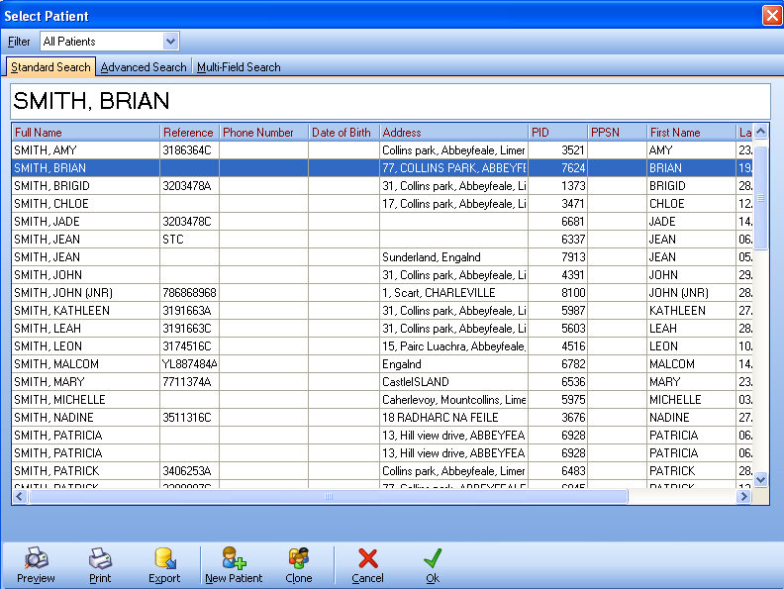

How do I insert a new dispense?

- Hit F2 and select the Patient file
- Hit the Insert key or Click on the Insert button
- Select the Drug dispensed
- Enter the quantity Dispensed
- Enter the quantity Prescribed
- Enter the Dosage instructions, (Alt & I will allow you to type instructions)
- Hit Alt & N to insert another item, or Hit F12 to complete the drug entry
- Confirm that all the details are correct on the Confirm Dispense screen and Hit F12 to complete the dispense, get a form number, print a Bag Label and print a Receipt
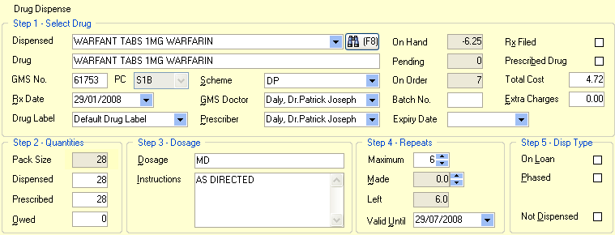

.
How do I repeat a dispense?

- Hit F2 and select the patients file
- Select each item you want to repeat, use the up and down arrow keys to move up and down the patients dispense history
- Hit Spacebar on the keyboard to select and de-select items
  - You can also select items by holding the Shift key and Clicking items required with the mouse
- Once all items are highlighted, Hit F8 or Click on the Repeat button at the bottom of the screen
- All items for the selected script will now be displayed on the Confirm Dispense screen and Drug Labels will have been printed
- Confirm that all the details are correct on the Confirm Dispense screen and Hit F12 to complete the dispense, get a form number, print a Bag Label and print a Receipt.

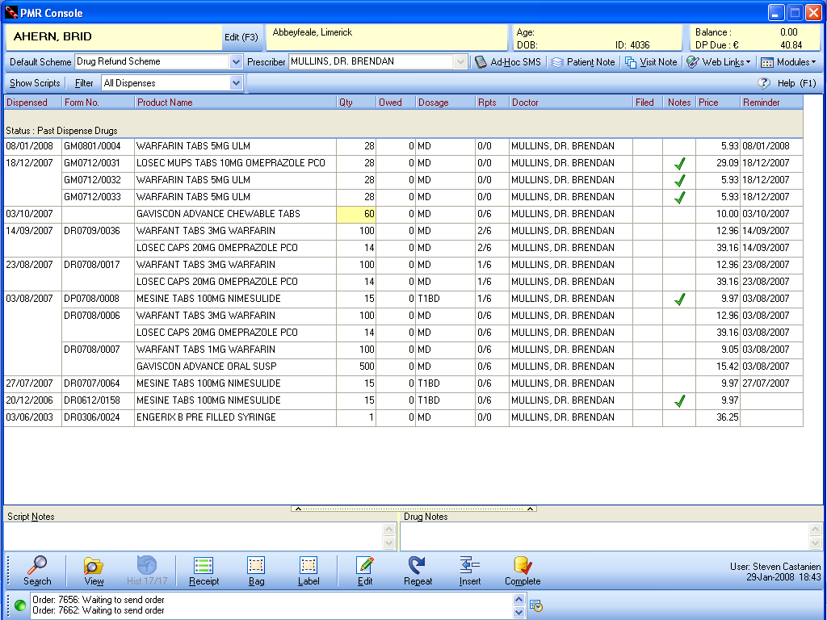
To insert a new patient

- Hit F2 or click on the Search button to open the Select Patient screen
- Enter the new patients name in full and Hit Return
- The Patient Maintenance window will appear, with the new patients name already entered
- Enter the patients Address
- Enter the patients Phone Number
- Select the Patients scheme from the Scheme Name dropdown list in the Schemes / Refs grid on the Details tab
- Enter the patients Scheme Card Reference number, if required
- Select the patient Prescriber (GMS Doctor). Type the Doctors surname or enter their GMS code
- Hit F12 or Alt & O to save the entry and close the Patient Maintenance window

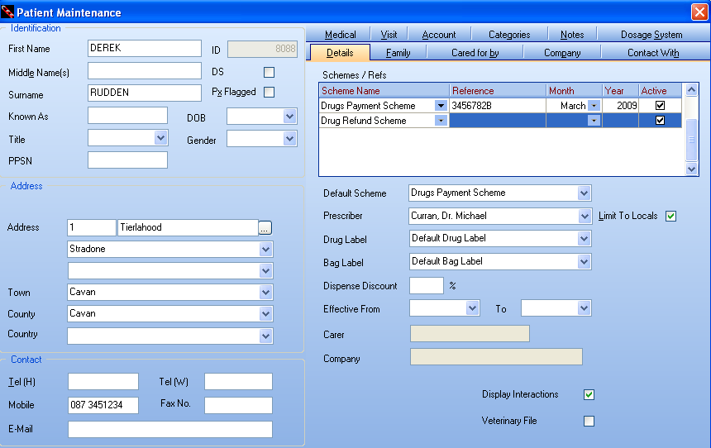
How do I view a family DPS balances?

- Hit F2 if you are in the PMR Console
- Select a patient record from the family in question
- The total current DP Balance due is displayed in the top right of the screen
- For more detail, Hit F5 to bring up the DPS Analysis window. This window holds all the DPS information for the patient. The Balance Due field is located in the top left of the window

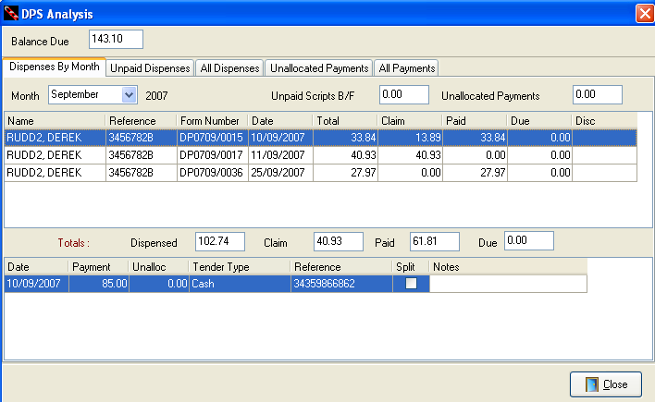
How do I Filter a patients Drug History?

- Select Patient who's history you wish to view
- Hit Alt & F to select a filter to apply
- Select the filter to apply
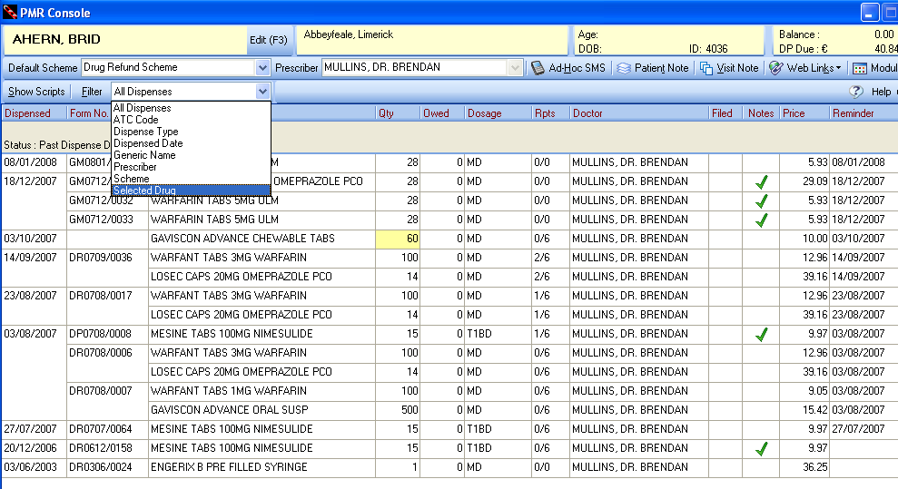

Review Practice Performance

The Practice Performance report in the reports module reports on Front of Shop performance, Dispensary performance and the Practice overall in a unique report omly made possible by Integra Rx and Integra POS integration.

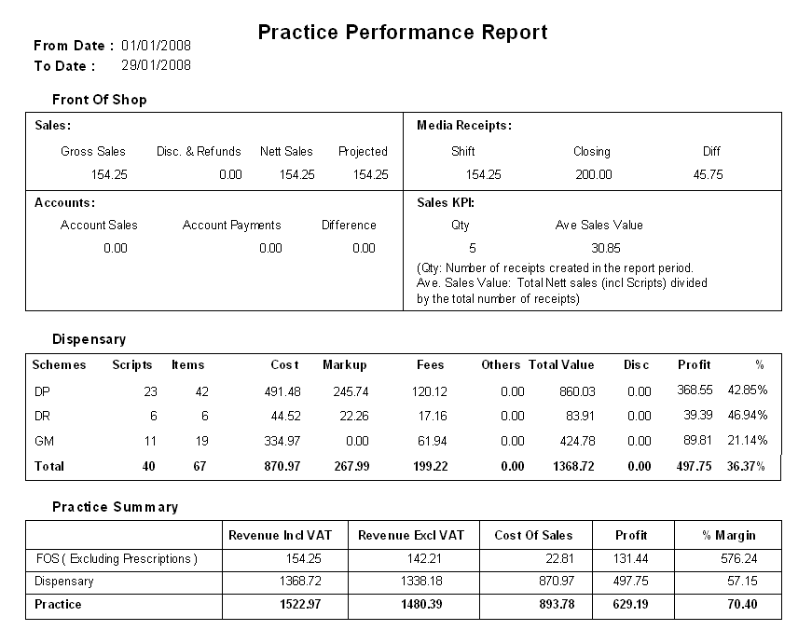
Review Sales Performance

The Practice Sales report in the reports module allows you to view 11 sales metrics over the past 12 months and compare those figures with last and the year before that.

The metrics available are:
- Gross Sales Inclusive of Vat
- Discount and Refunds inclusive of Vat
- Nett Sales Inclusive of Vat
- Nett Sales Exclusive of Vat
- Cost Of Sales
- Gross Profit Margin achieved
- No of Items sold
- Average Sales
- No of Receipts / transactions
- Average Item per Receipt / transaction
- Average Value per Receipt / transaction

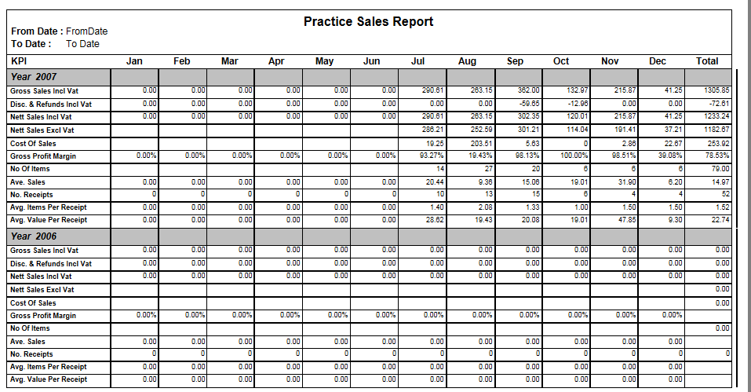
Orders module

Review your wants list – Pending orders, Shorts – Exceptions list and Validate received orders.

Pending Orders, wants list
- Bonus information is displayed in real time as you review your pending order
- Hold items on a Wants list to be ordered at a later time
- Fully configurable listing

Order Validation
- Unique handheld PC for order validation
- Unique line discount function
- Unique Bonus Stock handling function
- Unique FIFO cost price tracking for Exact COS value
- Automatic Price Update File creation – never under price again

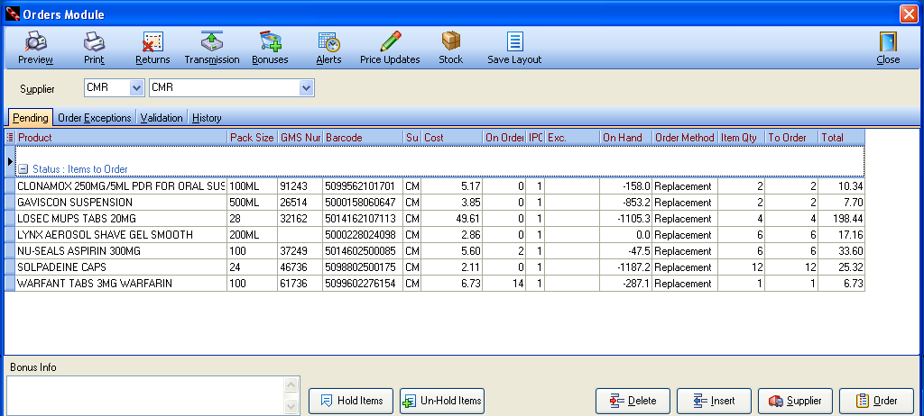
Stock Module

Easily maintain product information with this simple to use interface.

- Review Product Usage at a glance
- Select Pack replacement and Re-Order levels
- Define Dispense defaults, Dosage codes, Dispense qty’s etc.
- Create Reference information to appear on product selection
- Review Stock Movement history

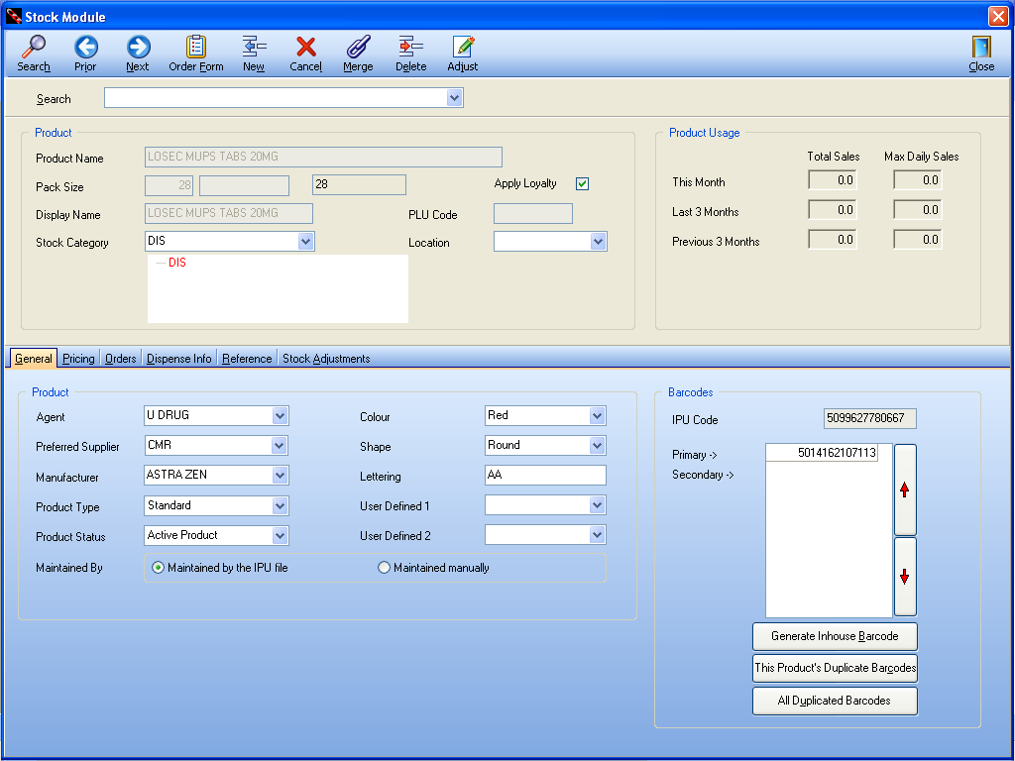

Features
Integra provide you a large number of unique features:

- Automatic DPS co-payment tracking
- Unique Prescription Cash Management module
- Second Generation PCRS Claims (XML), allowing you to correct exceptions before the early payment deadline
- No transaction fees on PCRS Claims
- Groundbreaking Monitored Dosage System for Nursing Homes and private patients.
- Possibly the best example of sheer volume of time that could be saved with Integra Rx is the MDS module - We have benchmarked existing users of the QIC Script MDS module where hours are needed to re-key repeat Phased dispenses where the end of a phase has been reached. This time lot and errors that occur would all be removed as repeating all patients in a 70 bed Nursing Home and printing their Cassette sheets (Nomad) or labels, takes 20 minutes.
- Unique Methadone Dosage module
- SMS text messaging sends Prescription Reminder and Prescription Collection messages directly to patient mobile phones and recoups the cost of this service from the patient
- Unique “Script Due” patient search filter, allows you to select patients due for repeat prescriptions today allowing you to prepare regular patients scripts. The Automatic Collection SMS message will then be sent to prompt patients to present for their prescription
- Multi-Store System, proven to be scalable from 1 to over 200 sites
- Centralised selected store functions
- Global visibility of multiple stores
- Unique data mining and business analysis technology: adds real value through the representation of the facts about the pharmacy, staff and patients. Integra materialises the value of the information gathered in the pharmacy by allowing it to be easily and quickly analysed. Most software packages offer some form of reporting capabilities, but Integra proposes a unique analytics offering, providing new and innovative clinical and retail analysis.

Integra HO features:
- Having aggregated data available for reporting at your Head Office will give true control pharmacy operations. Ocuco have obtained invaluable experience with this type of integration in our partnership with Vision Express.
From a store’s perspective, mundane daily, weekly and monthly administrative tasks currently required to update head office of current events will be done away with, leaving staff more time for Patients and value added activities.
Combining this with powerful reporting capabilities, and with the ease of maintaining consolidated data for all stores connected to the system (“update-once” technology) can result in saving hundreds of man hours.

Part 3 :
Reports Pack

Practice performance report

Key feature:
- 1 parameter to define the report output – Date Range
- Allows practice owners and managers to review Daily, Weekly or monthly practice performance on a single page!!
- The report has three sections, reporting on Front of Shop, Dispensary and overall Practice Summary. Integra is the ONLY Pharmacy Management system in Ireland that provides a single Turnover figure for the practice, or group, as a whole.
Key benefit:
- Report on performance over any period required
- Review each of the four Front of Shops quadrants:
    - Sales –
    - Media Receipts – cash, cheques, credit cards etc. What the till says versus what was counted
    - Accounts – Credit given and payments received
    - Sales KPI’s – How many transactions were completed, what was the average value achieved. €12 been a target value to achieve
- Track and monitor Dispensary volumes.
Review overall Profitability. Very important at all times to keep an eye on costs versus sales but especially now.
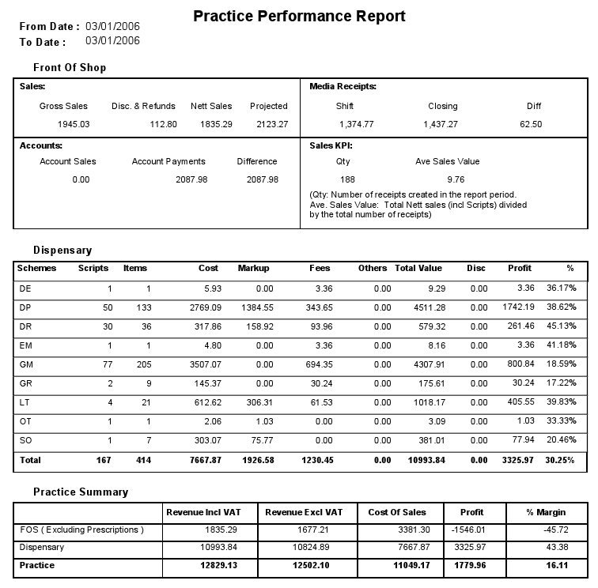

Practice sale analysis

Key feature:
- 2 parameters to define the report output – Date range and Staff Member
- Allows practice owners and managers to report on Monthly practice sales over 11 metrics, over 12 months over 3 years. This is a very powerful analytical report.
- Metrics reported on:
    - Gross Sales Incl of VAT
    - Discounts & Refunds Incl of VAT
    - Nett Sales Incl of VAT
    - Nett Sales Excl of VAT
    - Cost of Sales
    - Gross Profit Margin
    - Number of items sold
    - Average sales value
    - Number of receipts issued (the number of transactions at the tills)
    - Average number of items per receipt (transaction)
    - Average Value per Receipt
Key benefit:
- Track how the business has preformed last month compared with the month before, or the same month last year
- Track average sales values to maintain margins
- Track performance of individual staff members
- Ensure that Margins are been maximised each month and respond to dips.
- Forecast dips in performance from previous years and take proactive action
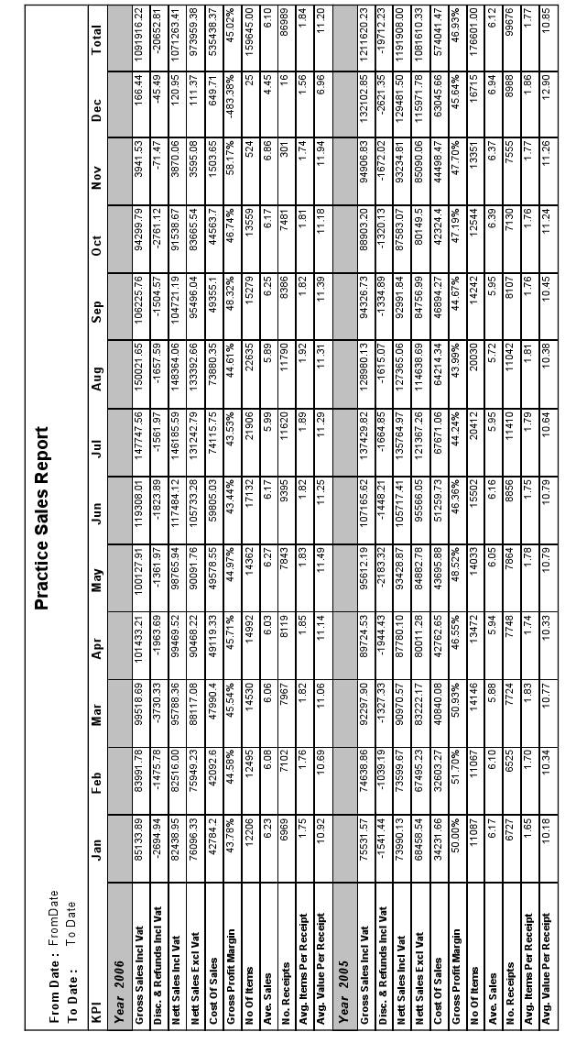

Category sales analysis

Key feature:
- 4 parameters to define the report output
- The report lists the number of items sold, total sales value, the % of overall sales that this represents, Cost of those sales, actual profit and percentage margin for all categories or for a specified category.
- In short, this report lets you see how each product group or category is performing in your practice
Key benefit:
- At a glance, ensure that margins achieved are in-line with target. Categories that are identified as under-performing can have a Product Sales Analysis report run which will highlight the under-performing products within the stock category.
- Products can be moved between categories with easy – Bulk Update module
- Products moved keep their sales history
- Promotions run for a given product group or sub-group can be tracked to assess the success of the promotion
- Shelf space and product placement can be defined by reviewing category performance
- This is the next most powerful report after the Practice Sales Analysis report.

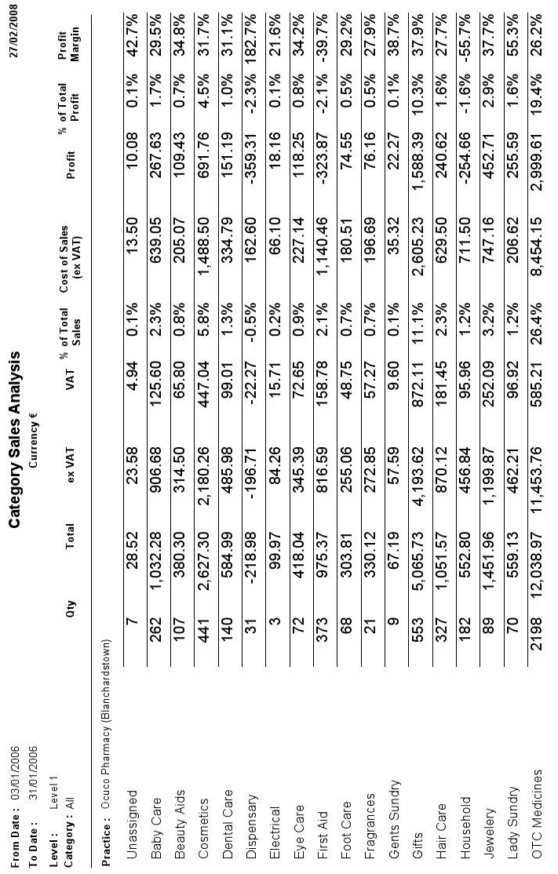

Daily prescription report

- 4 parameters to define the report output
- Audit of dispensed items as required by the Pharmaceutical Society of Ireland. This report can be run for any date range.

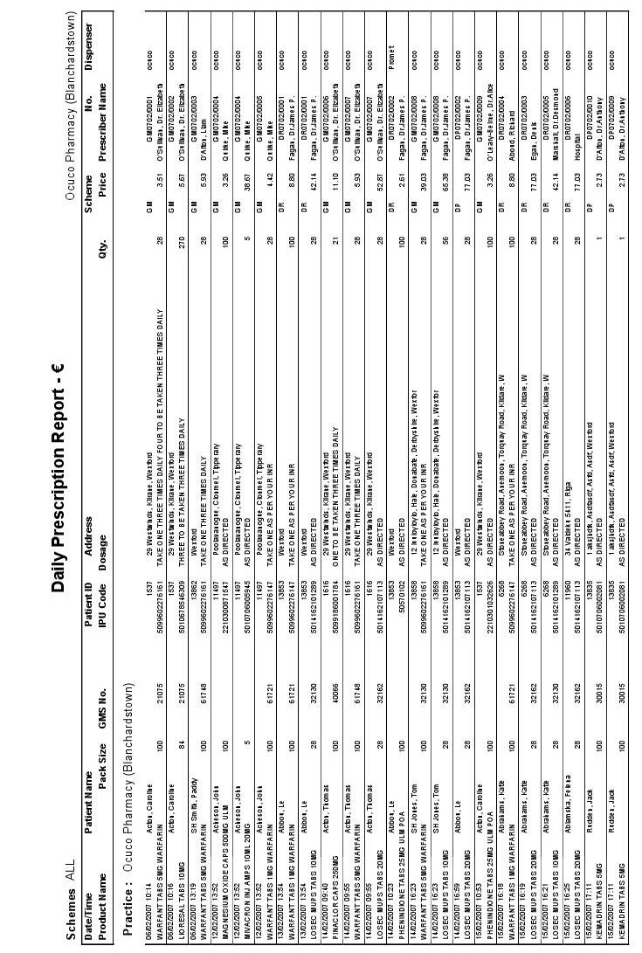

Controlled drug report

- 4 parameters to define the report output
- Audit of Controlled Drugs dispensed as required by the Pharmaceutical Society of Ireland. This report can be run for any date range.
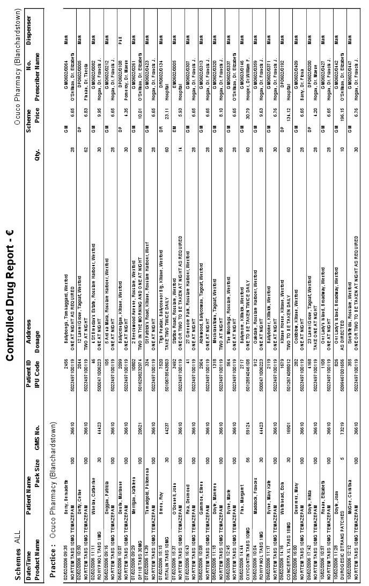

Patient analysis

Key feature:
- 9 parameters to define the report output
- Allows users to report on which medications are been taking by a specified patient, a specified family or all patients, prescribed by who and in what Dosage.
Key benefit:
- Very useful report when comparing Patient histories when making a dispensing decision
- View prescribing patterns among Nursing Home patients in general or for a specified patient. The Product analysis report will only report on one item, where as the patient analysis report lists all items dispensed to Nursing Home patients.
- Also useful for checking on Loaned or Owed items for a specified patient.

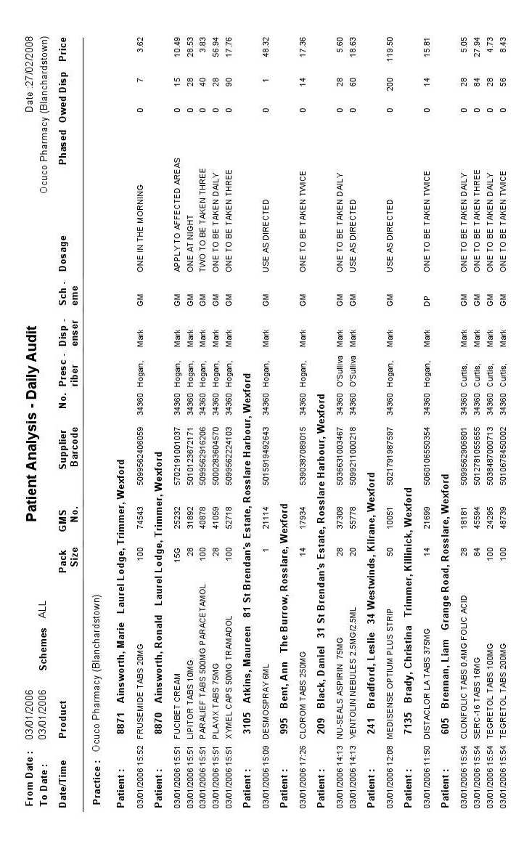

Product analysis report

Key feature:
- 11 parameters to define the report output
- Allows users to report on which patients are taking a specified medication, prescribed by who and in what Dosage.
Key benefit:
- Very useful report when comparing Dosage histories for a specified medication when making a dispensing decision or making ordering decisions
- View prescribing patterns among Nursing Home patients in general or for a specified item.

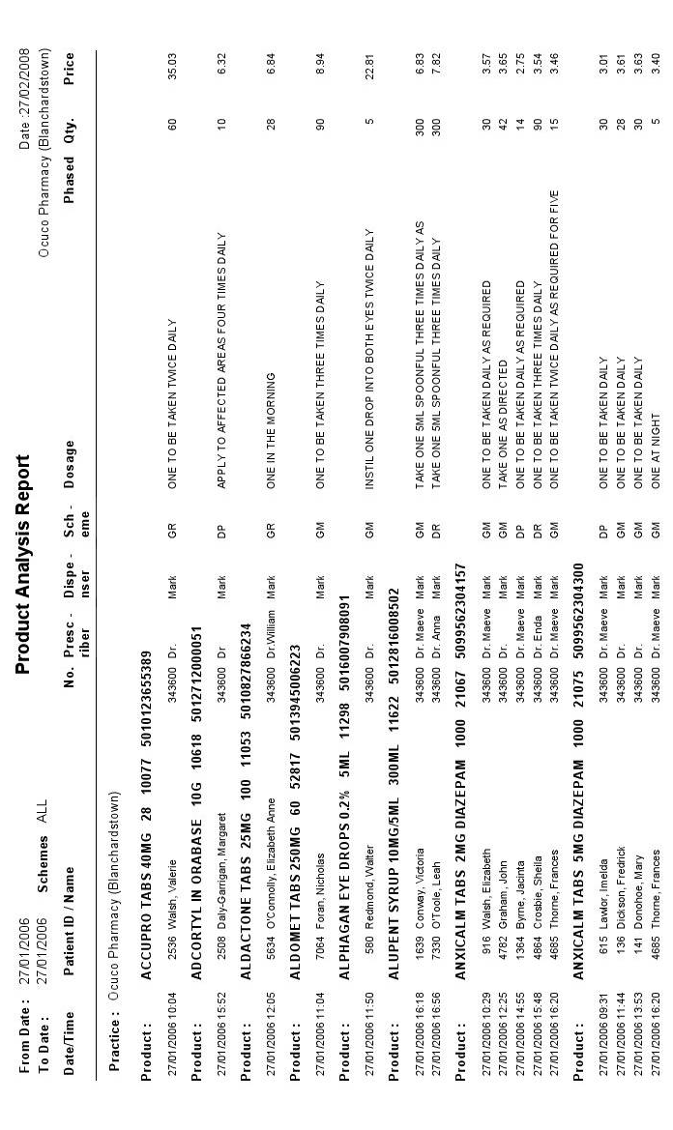

Stock take adjustments report

Key feature:
- 1 Parameter to define the report output – Stock Take ID
- Lists all products counted during the stock take and notes the Adjustment in Qty on Hand.
Key benefit:
- This report allows practice owners and managers to review the consistency of order validation within the practice. If orders are not getting validated, there will be many Stock Adjustments on the report which means that the Cost of Sales value on many products may be compromised and therefore profit and margin calculates on other reports will not be accurate.
- The Stock Adjustments report allows practice owners and managers to monitor general stock shrinkage and pilferage
- Having floor staff run a Stock Adjustment report on their respective sections on a regular basis, ensures that Practice SOP’s are been followed and that each section of the shop is been managed.

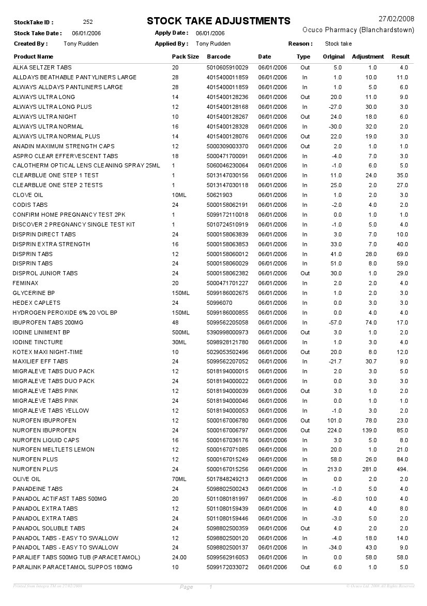

MDS cassette sheet

Key feature:
- Only required by Practices supplying medication to Nursing Homes where those homes employ a Nomand, or similar, weekly Cassette system
- Once configured, this report is automatically generated for every patient in the home requiring medication for the current cycle
Key benefit:
- Cheaper consumable costs. Integra Rx prints all forms to blank A4 paper, so no need to purchase expensive pre-printed fan-fold reams of paper
- As Integra Rx does not require a dot matrix printer when printing reports, the print for Cassette sheets delivered to the Nursing Home is of a much higher quality. This reduces confusing in the nursing home, thus reducing calls to the practice and increasing patient safety

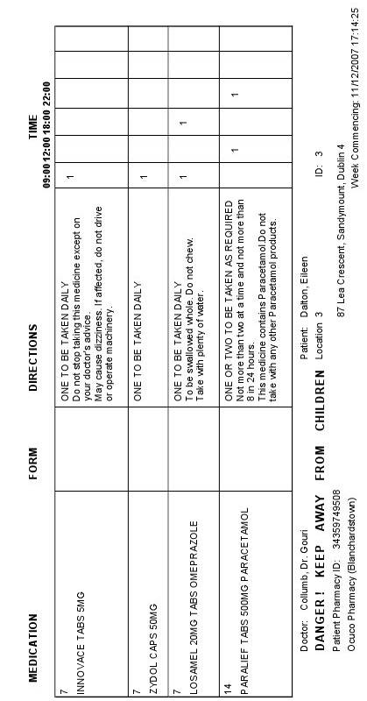

MAR sheet weekly format

Key feature:
- Only required by Practices supplying medication to Nursing Homes where those homes have medication delivered weekly and require a MAR sheet for each patient
- Once configured, this report is automatically generated for every patient in the home requiring medication for the current cycle
Key benefit:
- Cheaper consumable costs. Integra Rx prints all forms to blank A4 paper, so no need to purchase expensive pre-printed fan-fold reams of paper
- As Integra Rx does not require a dot matrix printer when printing reports, the print for MAR sheets delivered to the Nursing Home is of a much higher quality. This reduces confusing in the nursing home, thus reducing calls to the practice and increasing patient safety
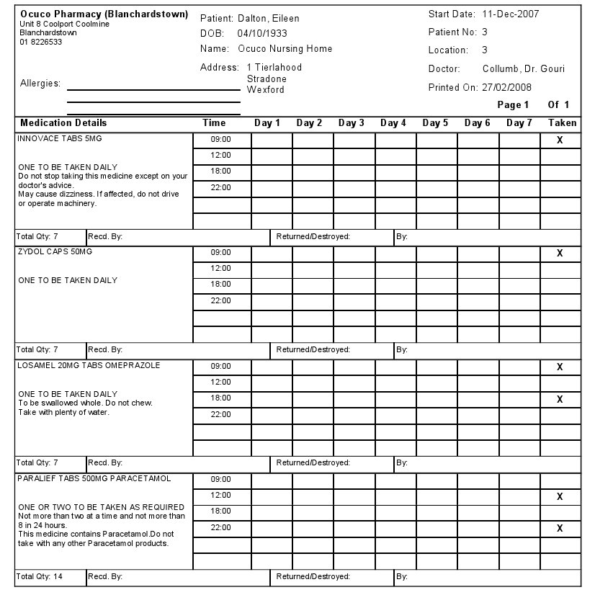

MAR sheet monthly format (days horizontal)

Key feature:
- Only required by Practices supplying medication to Nursing Homes where those homes have medication delivered monthly and require a MAR sheet for each patient
- Once configured, this report is automatically generated for every patient in the home requiring medication for the current cycle
- Each day number is listed horizontally across the page. Ideal for smaller nursing homes where only one nurse will be dispensing medication on any given day.
Key benefit:
- Cheaper consumable costs. Integra Rx prints all forms to blank A4 paper, so no need to purchase expensive pre-printed fan-fold reams of paper
- As Integra Rx does not require a dot matrix printer when printing reports, the print for MAR sheets delivered to the Nursing Home is of a much higher quality. This reduces confusing in the nursing home, thus reducing calls to the practice and increasing patient safety
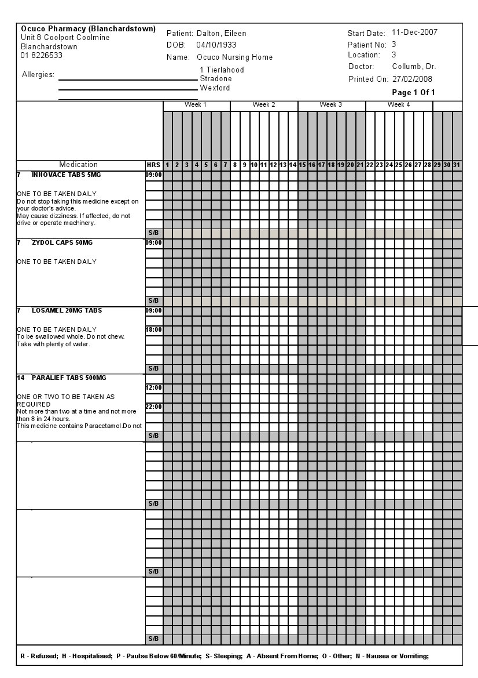

MAR sheet monthly format (days vertical)

Key feature:
- Only required by Practices supplying medication to Nursing Homes where those homes have medication delivered monthly and require a MAR sheet for each patient
- Once configured, this report is automatically generated for every patient in the home requiring medication for the current cycle
- Each day number is listed vertically across the page. This would be considered the more standard MAR sheet used by Nursing Homes. Each dispensing for each day can be signed for.
Key benefit:
- Cheaper consumable costs. Integra Rx prints all forms to blank A4 paper, so no need to purchase expensive pre-printed fan-fold reams of paper
- As Integra Rx does not require a dot matrix printer when printing reports, the print for MAR sheets delivered to the Nursing Home is of a much higher quality. This reduces confusing in the nursing home, thus reducing calls to the practice and increasing patient safety
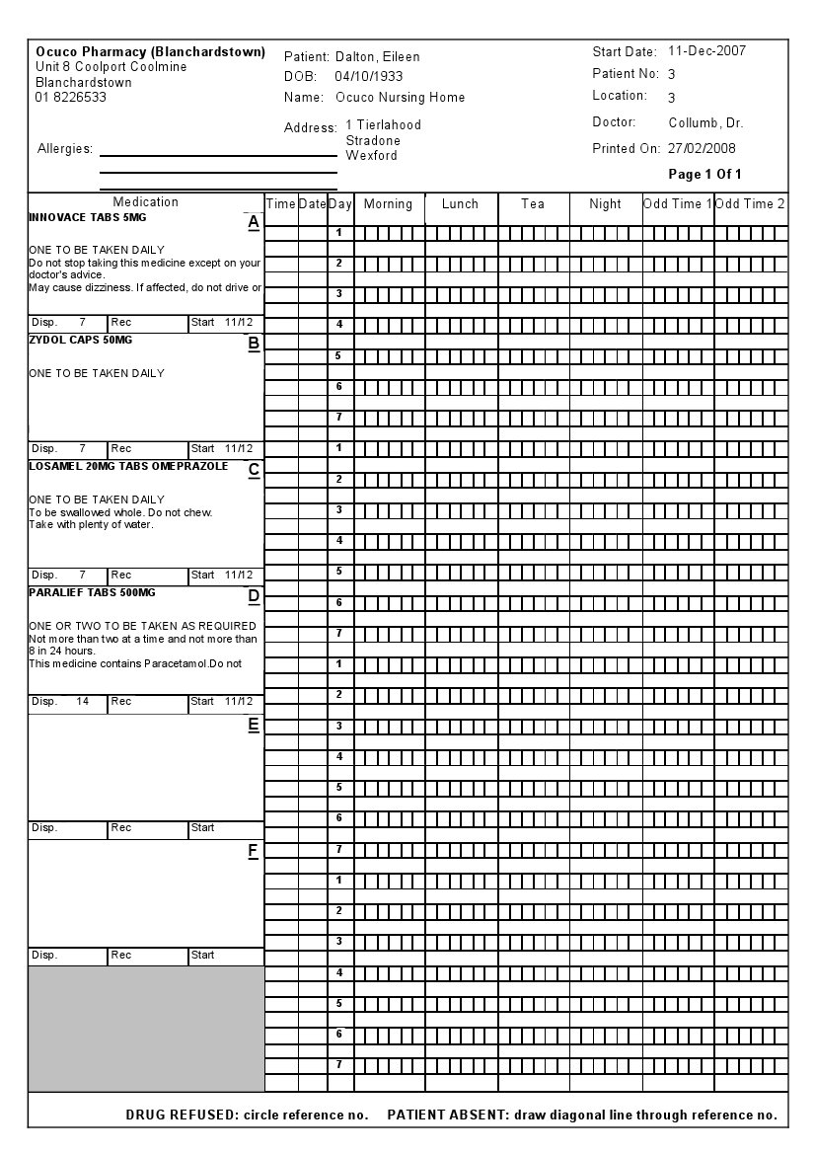

MAR order form
